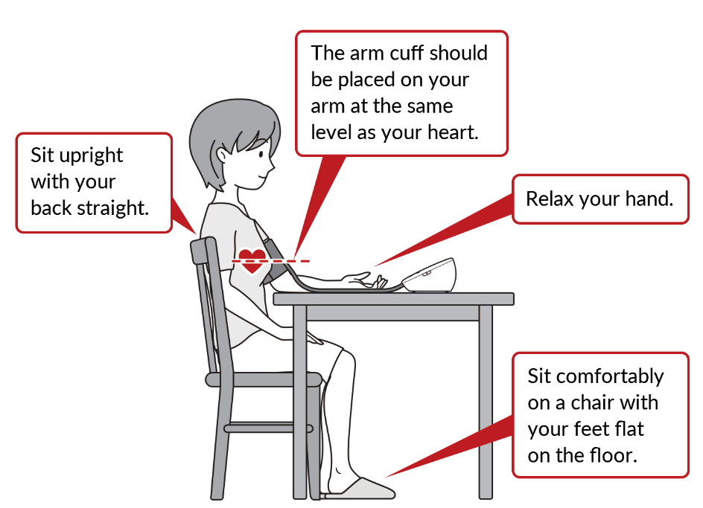
How to Properly Take Your Blood Pressure at Home

30 minutes Before Your Blood Pressure is Taken:
-No nicotine, caffeine, or exercise

Immediately Before Your Blood Pressure is Taken:
1. Empty your bladder.
2. Sit down in a chair:
- Put your feet flat on the floor. Your feet should not dangle or be crossed.
- Make sure your back is against the chair.
- Rest your arm on a surface that is at the level of your heart.
3. Put the blood pressure cuff on your bare upper arm. Please do NOT use a wrist cuff. Rest your arm like shown in the picture. The “artery” mark on the cuff should be in the center of your upper arm.
4. Sit still for 5 minutes and do not talk, text, or play on your electronic devices.
5. Push the button on the blood pressure monitor to take your blood pressure. Take nice slow breaths and relax!
6. Record your blood pressure on your log and bring your log with you to every appointment.
8. Bring your blood pressure cuff and monitor with you to your first appointment after you start checking your blood pressures at home.
9. If your top number of your blood pressure is 160 or more OR your bottom number of your blood pressure is 110 or more, wait 15 minutes and repeat your blood pressure. If your blood pressure is still elevated, call Generations Women’s Health at 330-956-5300.

