What we might see at…..
2D ultrasound is a grey-scale image in 2-dimensions. 3D ultrasound produces 3-dimensional images of your baby in flesh tones. The intricate details of your baby on 3D ultrasound are much more apparent and identifiable than on 2D grey-scale images. The 3D image is more “antique” in color rather than grey-scale. HD live imaging is a special imaging package that shows the more realistic pink skin colors of your baby. 4D ultrasounds are 3-dimensional images in real time imaging. In other words, it is like watching your baby dance, wiggle, squirm, and open and close his or her mouth from an observation window!

2D Image 3D Image HD Live Image

At Generations Women’s Health, we strive to give you the best images of your baby. We promise to make an effort to get you the best possible images of whatever parts of the baby that can be seen during the exam. The most common parts of your baby, depending on gestational age, are the face, ears, hands, feet, spine, and full body. If you desire to know gender and are planning a gender reveal event, we would encourage you to not schedule it in close proximity to your ultrasound in order to allow
for the event that your baby does not want to reveal itself! No representations or guarantees have been made concerning the quality of image that may be produced by the 3D/4D ultrasound in your particular case. Thus, we will look one additional time at no additional cost if the technician is not satisfied with the images. This is considered a novelty ultrasound
and the images are not reviewed by a radiologist or obstetrician. They are not able to be used for diagnostic purposes.

6555 Frank avenue north canton, OHIO 44720 330-956-5300
dk

3D/4D IMAGING

WOMEN’S HEALTH
GENERATIONS

7-15 weeks
At this time, the baby is the size of a blueberry to an apple. Your baby is still developing and during an ultrasound,
you can see the baby as a whole
and watch him or her move.

9 weeks 3D image 14 weeks 3D Image 14 weeks 3D Image
with HD Live with HD Live

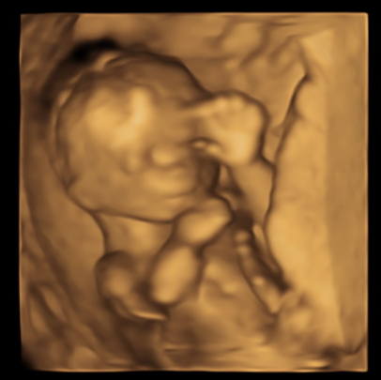
16-18 weeks
At this time, the baby is 4.5-5.5 inches long which is roughly the size of a bell pepper. During an ultrasound at this gestational age, you may be able to determine gender, see full body pictures, and enjoy the baby’s dance moves.

17 weeks 3D image

26-32 weeks
At this time, you are able to see a well-defined face as well
as your baby’s hands, feet, and spine. Your baby’s cheeks
become fuller and plumper with increasing age!

30 weeks 3D Image with HD Live

35 or more weeks
The ability to obtain images once your baby is in the later stages of pregnancy vary due to the baby’s
position within your pelvic bones.
Imaging at this point in pregnancy may be limited.

34 weeks 3D Image 35 weeks 3D Image
with HD Live

Pricing

These are single visit sessions at particular time frames during your pregnancy.

Package | Weeks of Gestation | Session Length | Listen to Heartbeat | Gender Determination | Email with all Images and Movie Clips | HD Live | Color Photo | Price*
First Glance | 7-12 | 10 minutes |  |  | x | X | x | $100.00
Look at Me | 16+ | 10-15 minutes | X | X | X | X | x | $100.00
Watch Me Grow | 26-32 | 15 minutes | X | X | X | X | X | $100.00

*Each additional baby (i.e. twins) is a $20.00 additional charge per Single Session.

3D/4D OB Ultrasound Guidelines

- Fees for 3D/4D ultrasounds are due at the time of scheduling the session.

- In the unfortunate event of pregnancy loss, early delivery, or if cancelling at least 48 hours prior to a single imaging session will result in a full refund.

- If you fail to cancel an appointment at least 48 hours prior to an imaging session for a reason outside of pregnancy loss or early delivery, there will be no refunds.

- Failure to arrive on time or keep your appointment wastes valuable time for other patients and will result in your visit being cancelled without a refund. There will be a $25.00 fee to reschedule that visit if you desire.

- No representations or guarantees have been made concerning the quality of image that may be produced by the 3D/4D ultrasound in your particular case. Thus, we will look one additional time at no additional cost if the technician is not satisfied with the images.

- This is considered a novelty ultrasound and the images are not reviewed by a radiologist or obstetrician. They are not able to be used for diagnostic purposes.

